Streamlining
Purpose: To investigate how the shape of an object affects its speed through the air.
Materials: Variables:

Instructions
- Measure the diameter of the muffin case
- Drop the case from about 1.5 meters
- Repeat 2 more times and record the results
- Spread the case to give a bigger diameter and more surface area: repeat steps 1-3
- Flatten/squish the case and repeat steps 1-3

Results:
Diameter (cm) | Time  1 | To  2 | Fall (sec)  3 | Average (sec) | Speed (cm/sec)

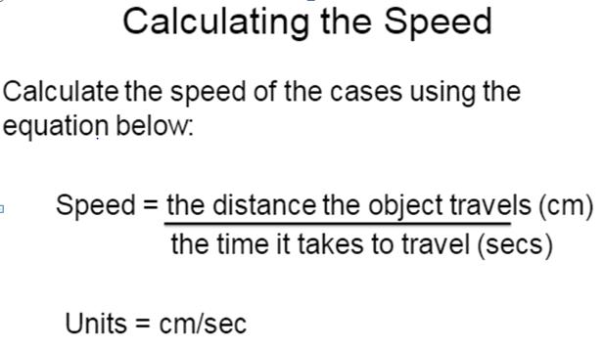

Graphing: We are going to make a graph to show the diameter and time it took for the muffin cases to fall.
X Axis: Diameter
Y Axis: Time

Post Lab questions
- Draw a picture of the muffin case showing the forces acting on it

- What is the force that pulls the case down? _______________________________________

- What is the name of the force that tries to push the case back up? _____________________________

- Why did the wider case take longer to fall?

- When the diameter of the case increase the speed _________________ this is because …

