Testing Solutions with Cabbage Juice Indicator
Ahh, the sweet smell of science! Enjoy this super smelly but really cool activity. Plug your nose and get ready to make your own red cabbage indicator that will test the acidity or alkalinity of certain liquids.
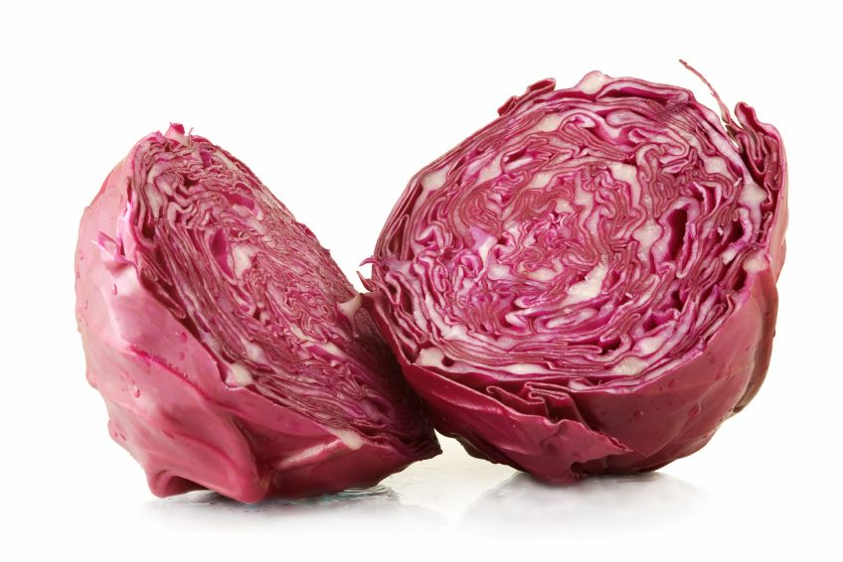
Purpose: The crime scene investigators are overwhelmed with work from the holidays and they need your help. There was break and enter at the strip mall down the road and they need to collect and examine the evidence. There was some a cup with a drink spilt that was found at the scene and it is your job is to identify what it is. They were able to extract some of the liquid from the crime scene so that you can test it.

Back Ground Information: When determining the identity of an unknown substance, crime lab experts must use testing procedures that give results that clearly distinguish one material from another. Forensic chemists often perform pH testing to determine the acidity of an unknown substance. The lower the number the more acidic a solution is and the higher the number the more basic so pH of 1 is very acidic and pH of 14 is very basic. pH values close to 7 are considered to be neutral. Pure water is neutral with a pH of 7.

Example: When testing an unknown solution, investigators may run the solution through a series of investigations including pH testing to identify the solution. Blood for example has a pH level near 7.

HOW DOES IT WORK?

Red cabbage contains a water-soluble pigment called anthocyanin that changes color when it is mixed with an acid or a base.

Red cabbage is just one of many indicators that are available to scientists. Some indicators start out colorless and turn blue or pink, for example, when they mix with a base. If there is no color change at all, the substance that you are testing is probably neutral, just like water.

In this lab we will test a variety of solutions to determine their pH based on the cabbage juice as the indicator. Here is a list of common pH levels for many common solutions.
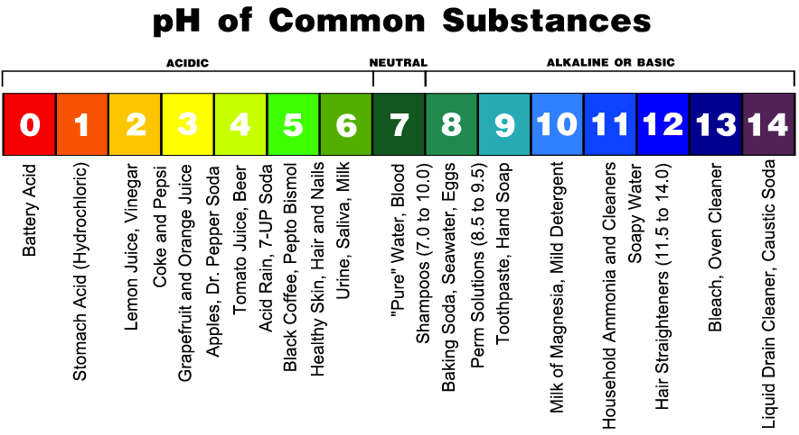

Mystery Solutions: This time I will not tell you what the solution is
Solution | Colour of solution |  | Colour with Indicator |  | pH

Solution | Colour of solution | Colour with Indicator:  Immediately | Colour with Indicator:  After a few minutes | pH
Lemon Juice
Vinegar

Coca-Cola

Root beer

Coffee

Gingerale

Milk

Distilled Water

Hand Soap

Cleaner

Bleach

Th

