The Leaf: Our Oxygen Factory

The word photosynthesis comes from the word photo, which means light, and synthesis, which means putting together.

Photosynthesis is the process by which plants produce their own food.

Plants take carbon dioxide from the air and water and minerals from the ground. Energy from the sun is trapped by chlorphyll and this energy is then used to combine carbon dioxide and water to form sugars.

The food (carbohydrates) is used for growth of leaves, stems, roots, woody tissue, fruits and nuts.

The O2 produced as a by-product, is put back into the atmosphere and used by organisms, in the process of cellular respiration, to produce energy for their own use.

The sugars are then converted into starches (sugars) . This process provides plants with food, but also returns oxygen to the atmosphere for us to breathe.

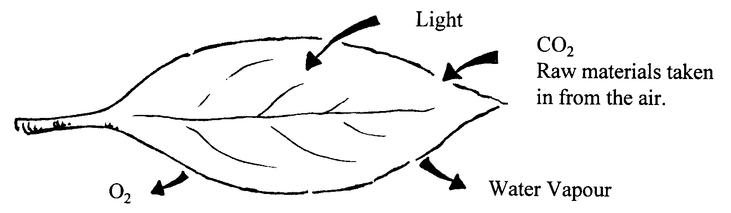

Photosynthetic equation

Three things I learned from the video

1.

2.

3.

Leaf’s changing colors

When winter approaches, out part of Earth receives less sunlight and the air grows colder. When this happens, trees prepare for winter.

Trees that drop their leaves (deciduous) seal the spots where the leaves are attached, this means that fluids cannot flow in and out of the leaves… therefore the leaves change color and fall off. If the tree did not seal the spots, it would die because of water loss.

In the warm seasons, leaves use photosynthesis to make food, in this process the trees lose a lot of water through the tiny holes in the leaves. During the winter, the trees do not receive enough water, and therefore cannot afford to keep the leaves.

During the winter, the trees are inactive or dormant, meaning they ARE NOT producing oxygen!
How Can We Survive With Less Oxygen In The Winter?
- Only one hemisphere of the earth is experiencing winter while the other half is having summer. Worldwide, about the same number of deciduous trees are actively producing oxygen year round. In tropical climates, trees do not become dormant and continue to produce oxygen all year.

DID YOU KNOW:
Trees make only about half of the world’s oxygen, with the rest coming from phytoplankton living in the ocean. Therefore, the amount of available oxygen stays consistent throughout the year.

