Name: Master #l&

Date:

Directions:
Leaf Classification Exercise

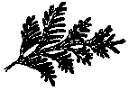
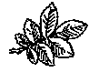
Beside each leaf picture record 1. type of leaf
    - shape of leaf or needle
    - margin type or arrangement of needles

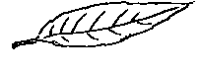
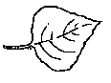
Write N/A (not applicable) on the line if necessary.

A. Willow | B. Plains Cottonwood
1. | 1.
2. | 2.
3. | 3.
C. Western Red Cedar | D. Wild Rose
1. | 1.
2. | 2.
3. | 3.

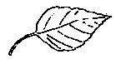
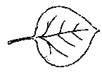
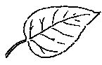
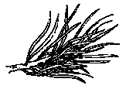
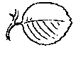
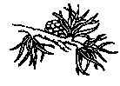
Master #l& cont'd

E. Box Elder | F. Aspen Poplar
1. | 1.
2. | 2.
3. | 3.
G. Balsam Poplar | H. Lodgepole Pine
1. | 1.
2. | 2.
3. | 3.
I. Saskatoon | J. Tamarack - Larch
1. | 1.
2. | 2.
3. | 3.

