Forest Ecosystem Balance

In a forest, every organism is interconnected. Everything in the forest is important for its survival.

Forest Team Members
Producers:

Ex)

Consumers:

Ex)

Decomposers:

Ex)

Types of Consumers

Primary consumer - the first consumer to eat the producer
Ex)

Secondary consumer - a consumer which eats the first consumer
Ex)

Tertiary consumer - a consumer which eats the second consumer
Ex)

Food Chains
- One way the forest is interconnected is through a food chain or food web.
- A food chain shows the flow of energy through a series of organisms.
- Each organism is food for the next higher organism
Example:

Food Web
- A more complex version of a food chain, it is many food chains connected together

Nutrient Cycle
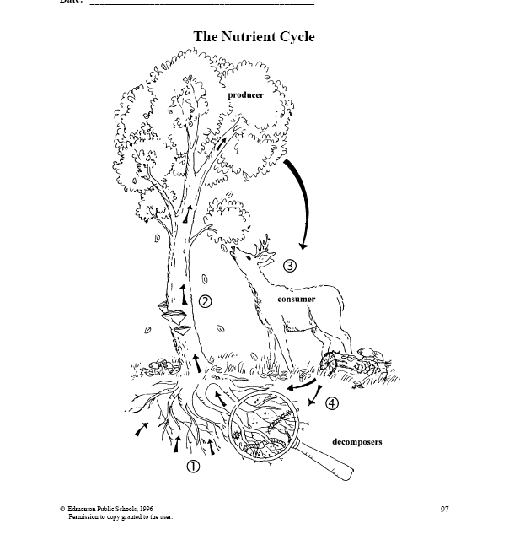
- Nutrients in the soil are absorbed by the _______ _______

- Nutrients travel up the trunk to the _____________

- Leaves fall to the ground or are eaten by the _______________

- __________________ break down dead plant or animal matter and return the ______________ to the soil, where the ____________begins again.

