**Finger printing**

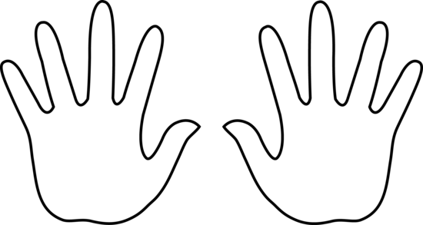

|  |  |  |  |  |  |
| --- | --- | --- | --- | --- | --- |
| Hand | Thumb | Pointer | Middle | Ring | Pinky |
| LEFT |  |  |  |  |  |
| RIGHT |  |  |  |  |  |

**What type of fingerprint are each of your fingers? Fill in the box below with the type of fingerprints you have**

