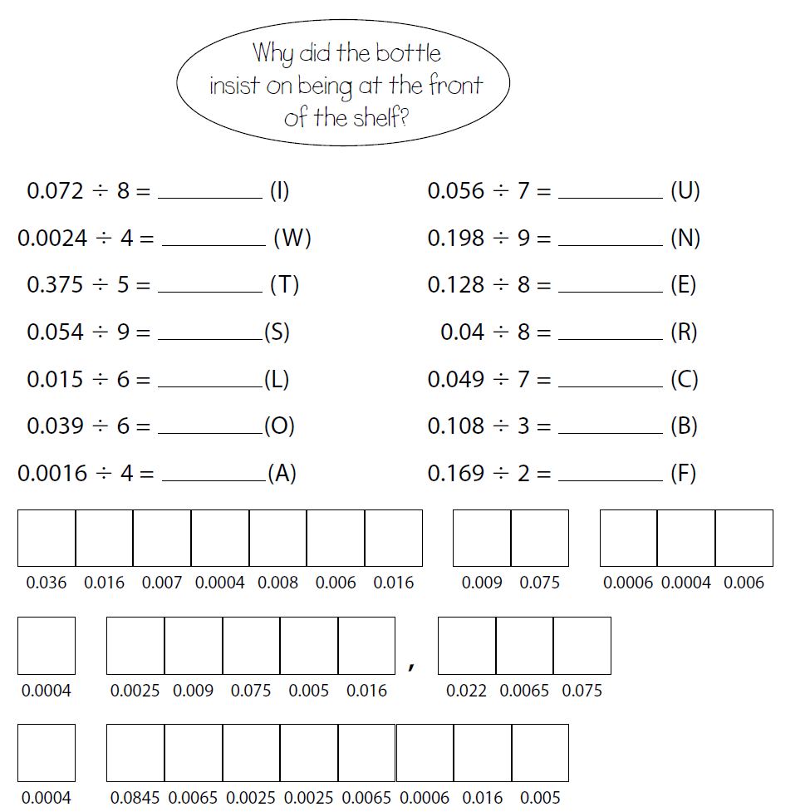

**You can also place the decimal point for the answer directly above the decimal point in the question**