**Practice Questions**

1. 
2. **Find pairs of congruent triangles, connect together with a line**



1. 
2. 
3. 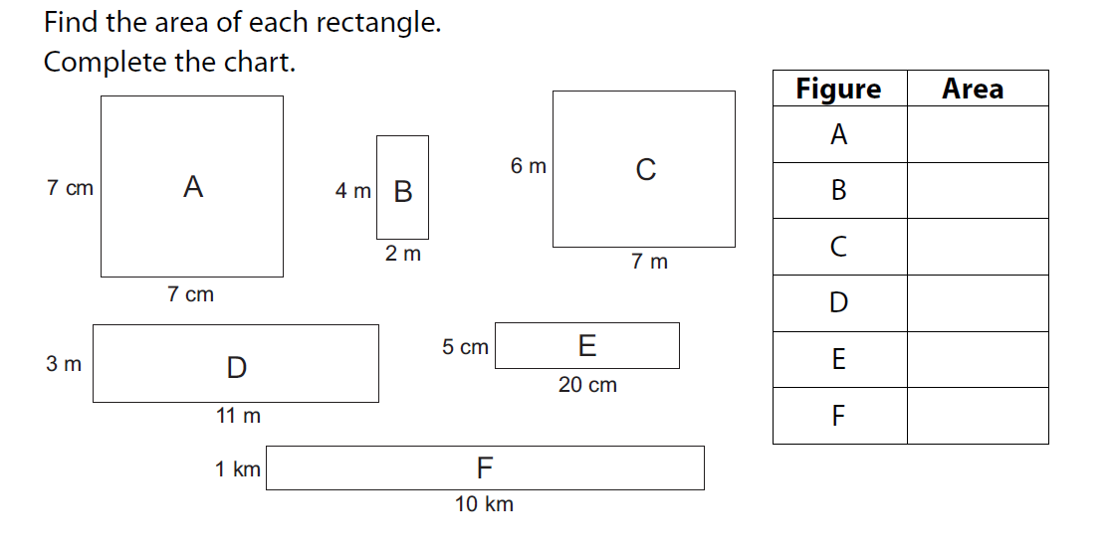





1. 

