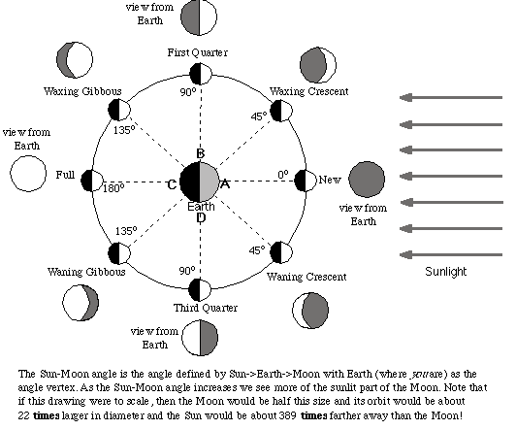
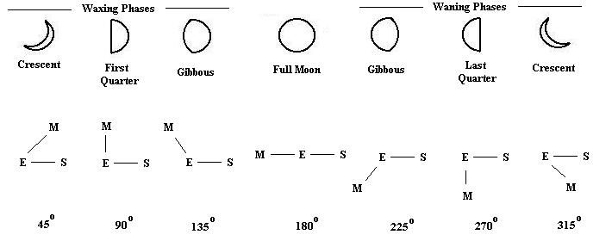

New Moon
- The moon is between the earth and the sun
- The moon makes a 180 degree angle or 0 degrees or 360 degrees depending what number you are starting at

Waxing Cresent
The moon is at a 45 degree angle
The moon is almost completely covered by the shadow

First Quarter
The moon makes a 90 degree angle
The moon is half covered by a shadow and half reflected light

Waxing Gibbous
The moon makes a 135 degree angle
The moon is almost completely lit by the reflection of the sun

Full Moon
The moon is completely lit by the reflection of the sun
The moon is on the opposite side: Sun Earth Moon
The moon is at a 180 degree angle with the sun and earth

Wanning Gibbous
The moon is beginning to be covered by a shadow
We only see a sliver of shadow
The moon makes a 45 degree angle or a 225 degree angle

Third Quarter
We see half the moon lit and half becoming a shadow
The moon is at a 90 degree angle or a 270 degrees

Wanning Cresent
The moon is almost completely covered by the shadow, only a sliver is lit by the suns reflection
The moon makes a 135 degree angle or 315 degrees

