**Table and Graph Practice**

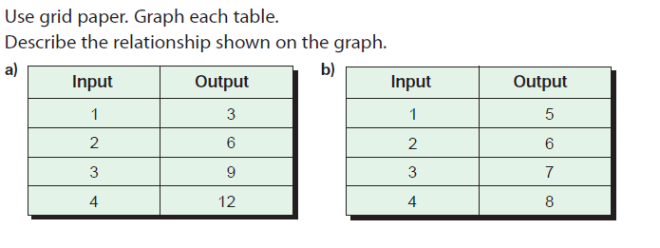

2. 

