Tree | Description | Habitat | Leaf/Needle | Cone/Fruit | Wood Use
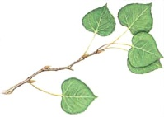
Aspen Poplar
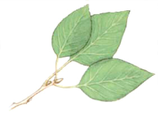
Balsm Poplar
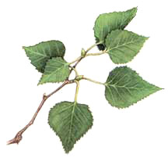
White Birch
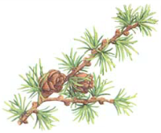
Tamark Larch
Tree | Description | Habitat | Leaf/Needle | Cone/Fruit | Wood Use
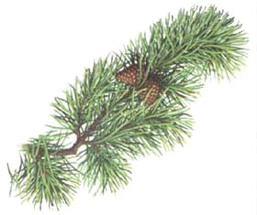
Lodge Pole Pine
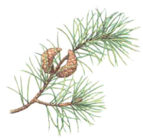
Jack Pine

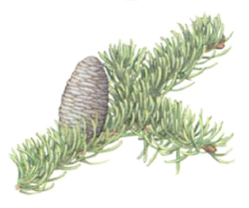

Balsm Fir

Tree | Description | Habitat | Leaf/Needle | Cone/Fruit | Wood Use
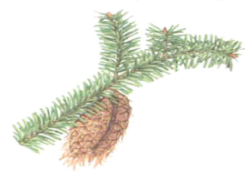
Rocky Mountain Douglas Fir

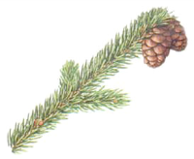
Black Spruce
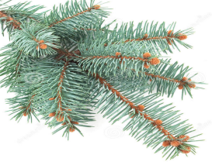
Blue Spruce

