Adaptations Needed To Help Birds Fly
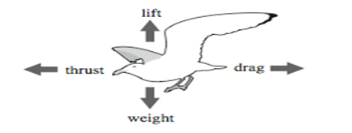
Take a look at the websites below to read about adaptations birds have that enable them to fly. Use the websites below to help you complete the chart below.
Anatomy: http://www.all-birds.com/Anatomy.htm
Wings: http://www.rspb.org.uk/youth/learn/adaptation/flight/wings.aspx
Skeleton: http://fsc.fernbank.edu/Birding/skeleton.htm
Flapping of wings: http://www.ornithopter.org/birdflight/flap.shtml
Feathers: http://www.earthlife.net/birds/feathers.html

Skeleton
Body Shape
Wing Structure
Tail
Propulsion
Feathers
Other

Using this information, why do you think penguins can’t fly?

Comparing Planes and Birds Flights Capabilities

Using the link below, see if you can find which birds and planes are similar. Record the bird and plane that match, as well as what makes them similar

http://sciencelearn.org.nz/Contexts/Flight/Sci-Media/Animations-and-Interactives/Wings-for-flight

Bird | Plane | Similarities

